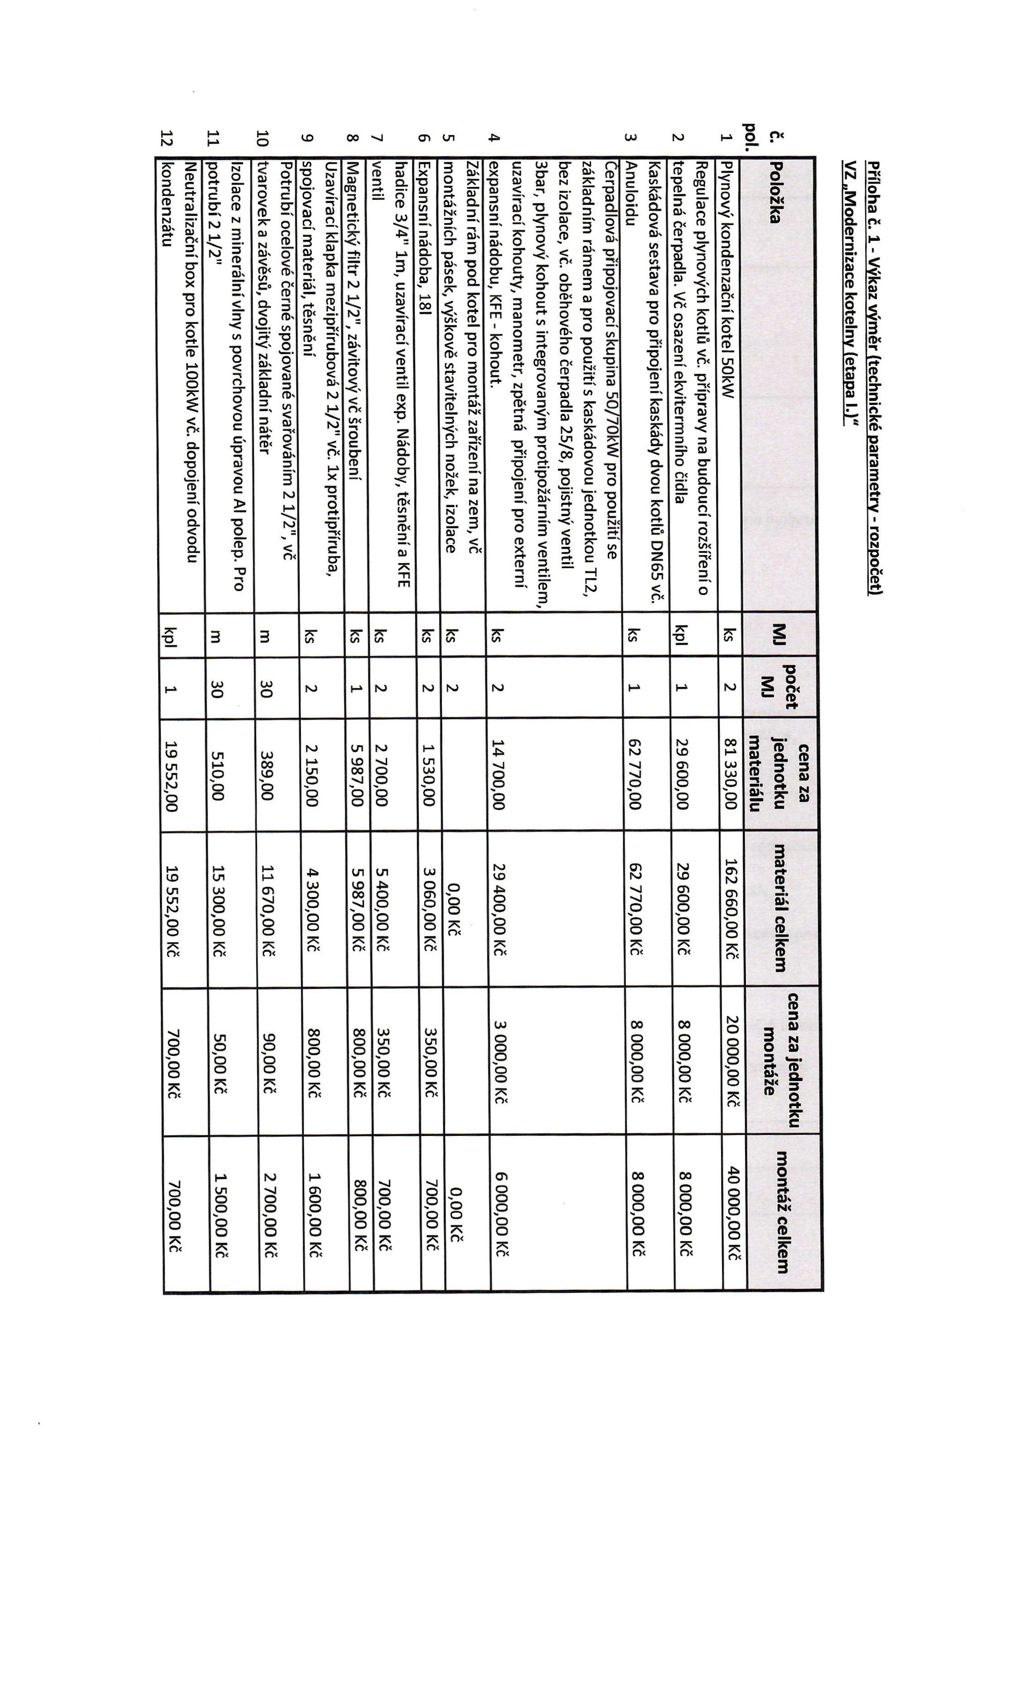

6(

PO



|  |  |  |  |  |  |  |  |  |  |  |  |  |  |  |  |  |  |  |  |  |  |  |  |  |  |  |  |  |  |  |  |  |  |  |  |  |  |  |  |  |  |  |  |  |  |  |  |  |  |  |  |  |  |  |  |  |  |  |  |  |  |  |  |  |  |  |  |  |  |  |  |  |  |  |  |  |  |  |  |  |  |  |  |  |  |  |  |  |  |  |  |  |  |  |  |  |  |  |  |  |  |  |  |  |  |  |  |  |  |  |  |  |  |  |  |  |  |  |  |  |  |  |  |  |  |  |  |  |  |  |  |  |  |  |  |  |  |  |  |  |  |  |  |  |  |  |
| --- | --- | --- | --- | --- | --- | --- | --- | --- | --- | --- | --- | --- | --- | --- | --- | --- | --- | --- | --- | --- | --- | --- | --- | --- | --- | --- | --- | --- | --- | --- | --- | --- | --- | --- | --- | --- | --- | --- | --- | --- | --- | --- | --- | --- | --- | --- | --- | --- | --- | --- | --- | --- | --- | --- | --- | --- | --- | --- | --- | --- | --- | --- | --- | --- | --- | --- | --- | --- | --- | --- | --- | --- | --- | --- | --- | --- | --- | --- | --- | --- | --- | --- | --- | --- | --- | --- | --- | --- | --- | --- | --- | --- | --- | --- | --- | --- | --- | --- | --- | --- | --- | --- | --- | --- | --- | --- | --- | --- | --- | --- | --- | --- | --- | --- | --- | --- | --- | --- | --- | --- | --- | --- | --- | --- | --- | --- | --- | --- | --- | --- | --- | --- | --- | --- | --- | --- | --- | --- | --- | --- | --- | --- | --- | --- | --- | --- |
| |  |  |  |  |  |  |  | | --- | --- | --- | --- | --- | --- | --- | | 0 | |  | ℃ |  | N | 0 | |  |  |  |  |  |  | |  |  |  |  |  | |  |  |  |  |  | |  |  |  |  |  | | |  |  |  |  |  |  |  |  |  |  |  |  |  |  |  |  |  | | --- | --- | --- | --- | --- | --- | --- | --- | --- | --- | --- | --- | --- | --- | --- | --- | --- | |  |  | 다 |  |  | 0℃ 응 로 을  o《 | ℃ | 0 |  | 2 0 | C | 6  3 |  |  | < 0  0 | 그 |  | |  |  |  |  |  |  |  | 3 |  |  |  |  |  |  |  |  | |  |  |  |  |  |  |  |  |  |  |  |  |  |  |  |  |  | |  |  |  |  |  |  |  |  |  |  |  |  |  |  |  |  | |  |  |  |  |  |  |  |  |  |  |  |  |  |  | 0 | 0 | 0 | | 글 | 8 | °  0 | 8  0  0 |  |  |  |  |  |  |  |  |  |  |  |  |  | |  |  |  |  |  |  |  |  |  |  |  |  |  |  |  |  |  | |

